Arrays and Pointers Assignment

Mandatory

1. What does the code below refer to? Extend the code and demonstrate the use of ptr to access the contents of a 2D array.

int (*ptr)[4];

[Refer the sample code in “array_ptr_simple.c”]

Ans: Here ptr is pointer that can point to an array of 4 integers. Since subscript have higher precedence than indirection, it is necessary to enclose the indirection operator and pointer name inside parentheses. Here the type of ptr is ‘pointer to an array of 4 integers’.

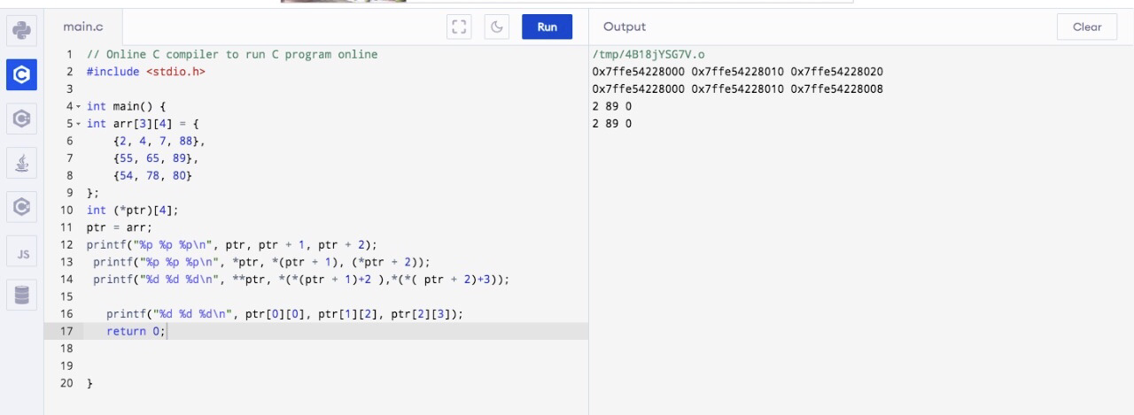

2.Refer the code in “array_ptr_simple_char.c”. Implement the missing functionality in the code marked with TBD1, TBD2…..